**BANK LOAN REPORT QUERY DOCUMENT**

**A.BANK LOAN REPORT | SUMMARY**

**KPI’s :**

**Total loan Applications**

SELECT COUNT(id) [Total_Loan_Applications] FROM bank_loan_data



**MTD Loan Applications**

SELECT COUNT(id) [MTD Total_Loan_Applications] FROM bank_loan_data

WHERE MONTH(issue_date)= 12 AND YEAR(issue_date)=2021

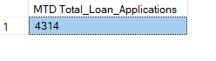

**PMTD Loan Applications**

SELECT COUNT(id) [PMTD Total_Loan_Applications] FROM bank_loan_data

WHERE MONTH(issue_date)= 11 AND YEAR(issue_date)=2021

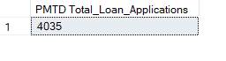

**Total Funded Amount**

SELECT SUM(loan_amount) AS Total_Funded_Amount FROM bank_loan_data

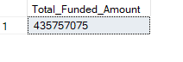

**MTD Total Funded Amount**

SELECT SUM(loan_amount) AS MTD_Total_Funded_Amount FROM bank_loan_data

WHERE MONTH(issue_date)=12 AND YEAR(issue_date)=2021

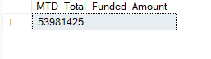

**PMTD Total Funded Amount**

SELECT SUM(loan_amount) AS PMTD_Total_Funded_Amount FROM bank_loan_data

WHERE MONTH(issue_date)=11 AND YEAR(issue_date)=2021

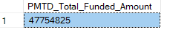

**Total Amount Received**

SELECT SUM(total_payment) AS Total_Amount_Received FROM bank_loan_data

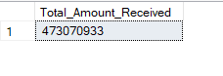

**MTD Total Amount Received**

SELECT SUM(total_payment) AS MTD_Total_Amount_Received FROM bank_loan_data

WHERE MONTH(issue_date)=12 AND YEAR(issue_date)=2021

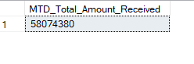

**PMTD Total Amount Received**

SELECT SUM(total_payment) AS PMTD_Total_Amount_Received FROM bank_loan_data

WHERE MONTH(issue_date)=11 AND YEAR(issue_date)=2021

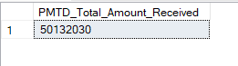

**Average Interest Rate**

SELECT ROUND(AVG(int_rate),4)*100 AS Avg_Interest_Rate FROM bank_loan_data

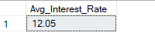

**MTD Average Interest Rate**

SELECT ROUND(AVG(int_rate),4)*100 AS MTD_Avg_Interest_Rate FROM bank_loan_data

WHERE MONTH(issue_date) = 12 AND YEAR(issue_date)=2021

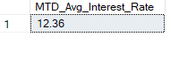

**PMTD Average Interest Rate**

SELECT ROUND(AVG(int_rate),4)*100 AS PMTD_Avg_Interest_Rate FROM bank_loan_data

WHERE MONTH(issue_date) = 11 AND YEAR(issue_date)=2021

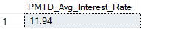

**Average DTI**

SELECT ROUND(AVG(dti),4)*100 AS Avg_DTI FROM bank_loan_data

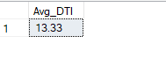

**MTD Average DTI**

SELECT ROUND(AVG(dti),4)*100 AS MTD_Avg_DTI FROM bank_loan_data

WHERE MONTH(issue_date)=12 AND YEAR(issue_date)=2021

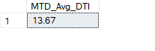

**PMTD Average DTI**

SELECT ROUND(AVG(dti),4)*100 AS PMTD_Avg_DTI FROM bank_loan_data

WHERE MONTH(issue_date)=11 AND YEAR(issue_date)=2021

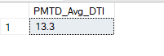

GOOD LOAN ISSUED

**Good Loan Application Percentage**

SELECT

(COUNT(CASE WHEN loan_status = 'Fully Paid' OR loan_status = 'Current' THEN id END)*100)

/

COUNT(id) AS Good_loan_percentage

FROM bank_loan_data



**Good Loan Applications**

SELECT COUNT(id)AS Good_Loan_Application FROM bank_loan_data

WHERE loan_status = 'Fully Paid' OR loan_status = 'Current'

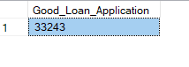**or we can do this by**

SELECT

(COUNT(CASE WHEN loan_status = 'Fully Paid' OR loan_status = 'Current' THEN id END )) [Good_loan_application]

FROM bank_loan_data

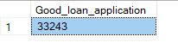

**Good Loan Funded Amount**

SELECT SUM(loan_amount) AS [Good_loan_funded_amount] FROM bank_loan_data

WHERE loan_status = 'Fully Paid' OR loan_status = 'Current'

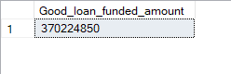

**Good Loan Total Received Amount**

SELECT SUM(total_payment) AS [Good_loan_received_amount] FROM bank_loan_data

WHERE loan_status = 'Fully Paid' OR loan_status = 'Current'

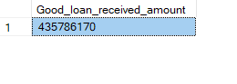

BAD LOAN ISSUED

**Bad Loan Application Percentage**

SELECT

(COUNT(CASE WHEN loan_status = 'Charged Off' THEN id END)*100)/

COUNT(id) AS Bad_Loan_Percentage

FROM bank_loan_data

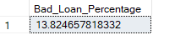

**Bad Loan Applications**

SELECT COUNT(id) AS Bad_Loan_Application FROM bank_loan_data

WHERE loan_status = 'Charged Off'

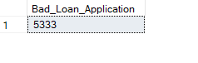

**Bad Loan Funded Amount**

SELECT SUM(loan_amount) AS [Bad_loan_funded_amount] FROM bank_loan_data

WHERE loan_status = 'Charged Off'

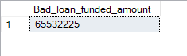

**Bad Loan Total Received Amount**

SELECT SUM(total_payment) AS [Bad_loan_received_amount] FROM bank_loan_data

WHERE loan_status = 'Charged Off'

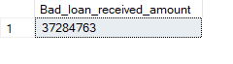

LOAN STATUS

SELECT

loan_status,

COUNT(id) AS Total_Loan_Applications,

SUM(total_payment) AS Total_Amount_Received,

SUM(loan_amount) AS Total_Funded_Amount,

ROUND(AVG(int_rate),4)*100 AS Interest_Rate,

ROUND(AVG(dti),4)*100 AS DTI

FROM

bank_loan_data

GROUP BY

loan_status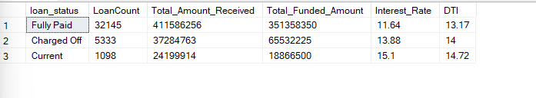

SELECT

loan_status,

SUM(total_payment) AS MTD_Total_Amount_Received,

SUM(loan_amount) AS MTD_Total_Funded_Amount

FROM bank_loan_data

WHERE MONTH(issue_date) = 12

GROUP BY loan_status

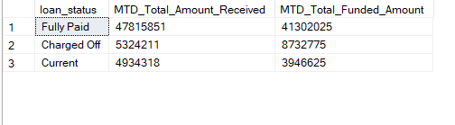 **B. BANK LOAN REPORT | OVERVIEW**

**MONTH**SELECT

MONTH(issue_date) AS Month_Munber,

DATENAME(MONTH, issue_date) AS Month_name,

COUNT(id) AS Total_Loan_Applications,

SUM(loan_amount) AS Total_Funded_Amount,

SUM(total_payment) AS Total_Amount_Received

FROM bank_loan_data

GROUP BY MONTH(issue_date), DATENAME(MONTH, issue_date)

ORDER BY MONTH(issue_date)  
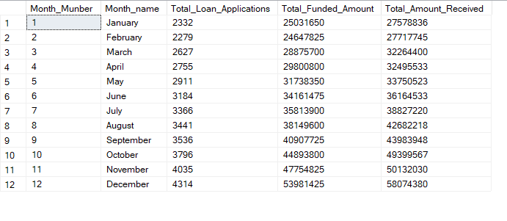

**STATE**SELECT

address_state AS State,

COUNT(id) AS Total_Loan_Applications,

SUM(loan_amount) AS Total_Funded_Amount,

SUM(total_payment) AS Total_Amount_Received

FROM bank_loan_data

GROUP BY address_state

ORDER BY address_state

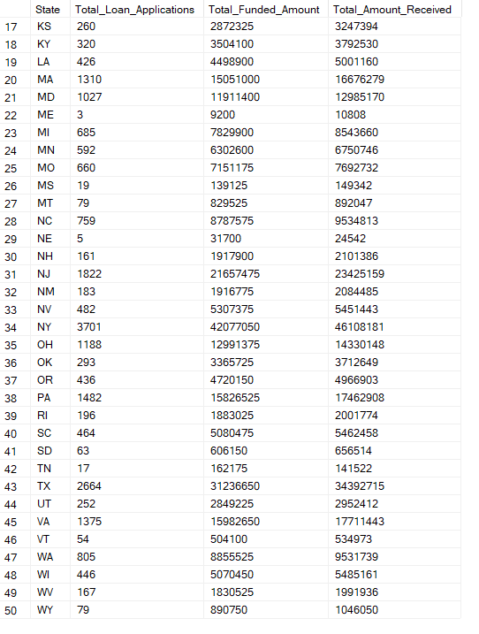

**TERM**SELECT

term AS Term,

COUNT(id) AS Total_Loan_Applications,

SUM(loan_amount) AS Total_Funded_Amount,

SUM(total_payment) AS Total_Amount_Received

FROM bank_loan_data

GROUP BY term

ORDER BY term  
  
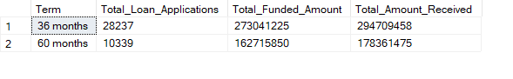**EMPLOYEE LENGTH**SELECT

emp_length AS Employee_Length,

COUNT(id) AS Total_Loan_Applications,

SUM(loan_amount) AS Total_Funded_Amount,

SUM(total_payment) AS Total_Amount_Received

FROM bank_loan_data

GROUP BY emp_length

ORDER BY emp_length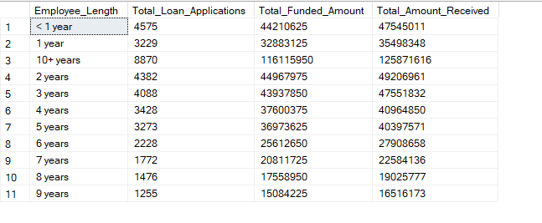

**PURPOSE**SELECT

purpose AS PURPOSE,

COUNT(id) AS Total_Loan_Applications,

SUM(loan_amount) AS Total_Funded_Amount,

SUM(total_payment) AS Total_Amount_Received

FROM bank_loan_data

GROUP BY purpose

ORDER BY purpose  
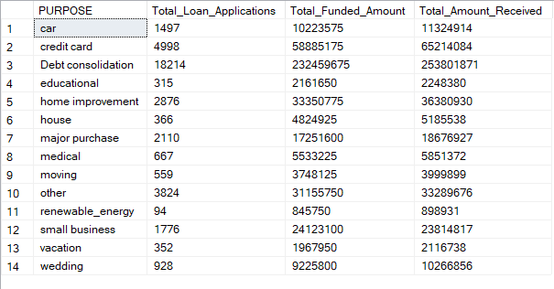

**HOME OWNERSHIP**

SELECT

home_ownership AS Home_Ownership,

COUNT(id) AS Total_Loan_Applications,

SUM(loan_amount) AS Total_Funded_Amount,

SUM(total_payment) AS Total_Amount_Received

FROM bank_loan_data

GROUP BY home_ownership

ORDER BY home_ownership  
